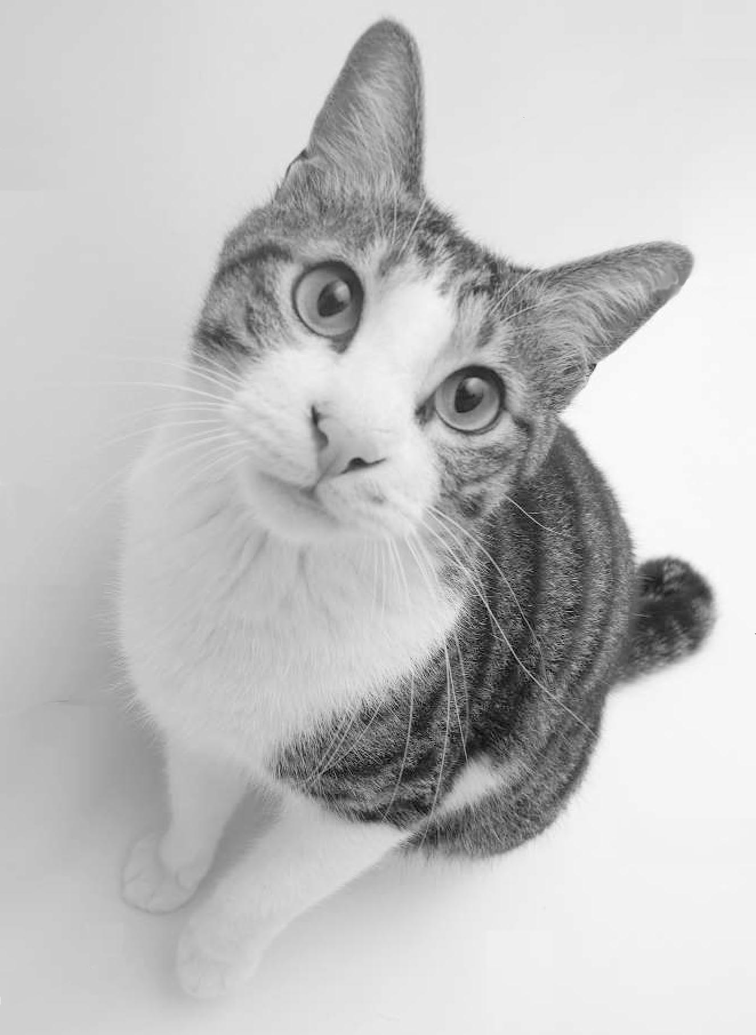

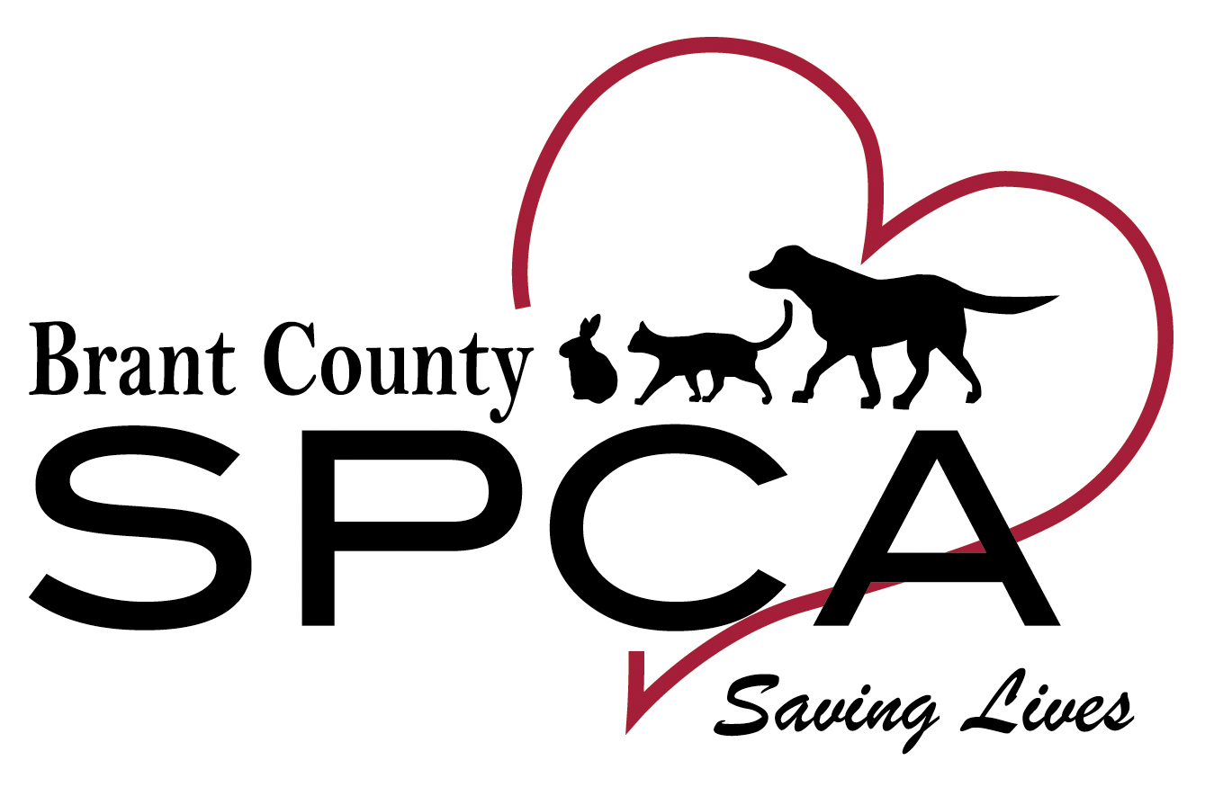

Distemper  
combo vaccine:  
**$15 per booster**

Deworming  
  
**$15**

Spay/neuter:  
**$175**

Microchip

$50

539 Mohawk St. Brantford, ON N3T 5M8 519-756-6620

Rabies  
vaccine:  
**$15**

Ear mite  
exam &   
treatment  
**$36**

Flea treatment:  
**$10**

Lifetime of love and companionship: **PRICELESS**

Physical exam:  
**$40**

I.D. Tag

**$6**

30 days of insurance **$10**

free pet insurs  
**$8.95**

Our adoption fee for adult cats (10 months and up) includes all this — **a value of over $360** **for only $75 (kittens $175)**. You also receive an adoption packet filled with valuable savings.

**What do you get when you adopt a  
cat or kitten from the Brant County SPCA?**

**ALL THIS!**