Cats and Communications
One of the most well-regarded cat behaviour experts in the world is Pam Johnson-Bennett, she has written many helpful books about cat behaviour. She once said " cats are the masters of communication".
Cats communicate through:
Scent: Cats produce pheromones (chemical scents) that are released through facial rubbing, scratching (cats' feet contain scent glands), and urinating. Facial pheromones considered "friendly" scents, that cats release when they are feeling relaxed, by contrast, urine pheromones (marking) is an indication of stress which can be caused by other cats or another stressor in the environment.
Body Language: Cats communicate using their eyes, ears, whiskers, tail, hair and posture.

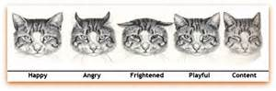
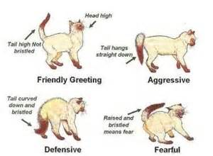
Vocalizations: Cats make a variety of sounds to communicate, including friendly/welcoming sounds (e.g. purring, chirping, meowing and trilling), and other sounds that are meant to create distance (e.g. hissing, spitting and growling).

