Aggressive Behaviour in Cats
Let's start by looking at what a cat's body language can tell us.

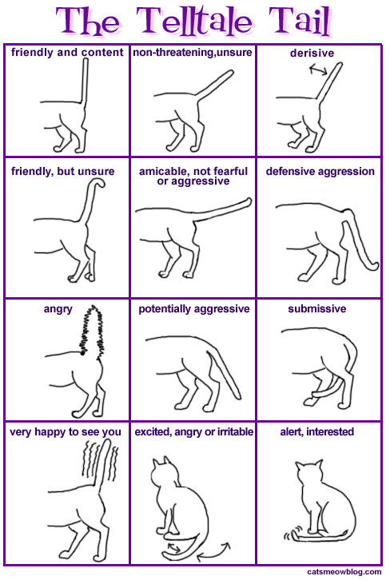

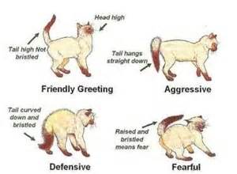

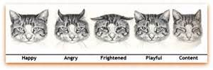

Cats communicate with their eyes, ears, whiskers, tail, hair and posture.

In this section we will look at different types of aggression in cats and how to redirect that aggression. This does not include feral cats. Feral cats are those that have been born and lived outside that have chosen not to interact with people whenever possible.

Petting -Induced Aggression
This refers to a cat that is being pet, the cat then becomes over stimulated or uncomfortable with where on their body they are being pet, how they are being pet, or the length of time they are being pet and seemingly out of the blue bites or scratches the person petting them.
This almost never happens without the cat giving a warning sign. These signs can be subtle, the swishing of the tail, the dilating of their pupils, a change in the position of the ears, whiskers, the bristling of its hair, sudden vocalization, or a glance back at the person. These are all ways cats use to indicate that they are experiencing discomfort, before taking action.
This type of behaviour can be resolved once the owner learns to read their cat's body language and to stop petting the cat if they show signs of being agitated. The owner should also learn where the cat does like to be pet (usually the head, chin, sometimes the back), and limit petting to those areas. The owner will also need to figure out how the cat likes to be pet. Is it long slow strokes, shorter scratches or something in between?

Signs
- The cat might be friendly and social, and sometimes like being pet, but sometimes swats or bites at the person's hands or arms while being pet.
- The cat might cause superficial scratches or bites, but typically not any significant injury.

Advice
- Pay close attention to where the cat likes and does not like to be pet on their body. Then only pet them where they are comfortable. Typically, this is on the top of their head, the back of their neck and chin. Some cats also enjoy their backs being pet. Most cats do NOT enjoy having their belly or chest pet.
- Pay attention to how the cat likes to be pet, and only pet them in the way that they are comfortable. Some cats prefer to be pet with quick, short strokes and others with slower, longer strokes.
- Watch for warning signs that the cat is getting agitated. These signs include: tail swishing, the hair on their back rising, skin twitching, the cat glancing back at the person doing the petting, sudden vocalization and shifting of position. Once you have learned the cat's warning signs stop petting the cat before they occur. E.g. if the cat starts swishing their tail at about the 2 minute mark, stop petting after 90 seconds. Over time, you will likely be able to gradually increase the length of time you can pet the cat so that the cat slowly becomes more comfortable with being pet for longer periods.
- Provide the cat with twice-daily interactive play and other types of environmental enrichment to keep them occupied. Cats that are under stimulated can be more likely to show petting-induced aggression.

Play Aggression

Cat's that exhibit play aggression are usually under-stimulated and are acting on their natural need to stalk and pounce, even if they are directing it towards an inappropriate target (i.e. a person or another cat).

Example- A cat named George was adopted about 2 years ago as a kitten. The cat loves his new owner and often seeks his attention. The new owner is concerned because several times a day, often in the morning and evening, George pounces on his new owner’s legs and feet when he is walking around. George also stalks and pounces on Franklin, the other cat in the home. The two cats often sleep near each other and otherwise seem to get along. While his new owner pets George every day, he doesn’t get many chances to play with him.

Play aggression is not like actual aggression because the cat is not trying to harm the person or other cat, nor is the cat fearful or upset. Play aggression is usually demonstrated by a cat that is not getting enough physical stimulation and is looking for a way to burn off energy. Chasing or pouncing on a person or another cat and then running away when the other person/animal reacts is a good way to be active when there are no other options. This behaviour can be annoying and can result in accidental injuries.

Signs
- The cat might be friendly and social but sometimes stalks and pounces on or chases another cat in the home
- The cat might be friendly and social but sometimes stalks and pounces on or chases a person walking by or pounces on them while they are sitting down or sleeping
- The cat might run away once the targeted person or cat reacts (screams/yells)
- Cause superficial scratches but does not cause significant injury
- Exhibits this behaviour in the mornings and evenings when cats have the most energy

Advice
- Identify at what time of day this is behaviour occurs and engage the cat in a 10-15 minute interactive play session around that time. The cat should have at least two interactive play sessions/day. Feeding the cat following the play session will make the cat relaxed and they are likely to fall asleep afterwards
- Provide the cat with other types of enrichment to keep them occupied. E.g. window perches, cardboard boxes or paper bags to explore and a rotation of solo toys to play with.
- If the cat tends to pounce on feet or legs when a person walks by, get the cat out of this habit by tossing treats or toys when walking by the cat, or distract the cat with an interactive toy before
the cat shows any initial reaction.

Fear-Based Aggression

Most cat aggression is fear-based. Figuring out how to make the cat feel safe and secure in their territory is most often the key to resolving this type of aggression. Cats can be fearful because they are ill or injured or because of a change in their home that they find upsetting. Changes in the home may seem minor to us but significant to the cat.

Example 1-When Esmerelda is alone with her owner, they describe her as the "sweetest cat". But whenever the owner has guests visit, Esmerelda "goes crazy". She will hiss, growl and if anyone dares go close to her she will run at them and starts swatting and biting.

Example 2-Max's owner bought a new furniture set and brought it home. Now Max is "flipping out”, pacing and growling. When his owner tried to comfort him, Max bit him.

Example 3-"redirected aggression". This can happen when a cat is startled suddenly by something, but they cannot get to the source (e.g. an outdoor cat or sound). One such case involved a woman who was talking to a friend on the phone while she was feeding her cat. She knocked over a glass pitcher that landed on the floor and shattered. The woman screamed and the cat attacked her leg.

Example 4-"pain induced aggression". A cat that is ill or in pain can react aggressively if approached or touched because they feel vulnerable. E.g. Tommy, and indoor/outdoor cat was injured in a fight with another cat while outside. Tommy's owner was unaware of the injury and when she went to brush Tommy she unintentionally caused him pain. Tommy turned and bit his owner.

Fear makes a cat feel vulnerable, as a result the cat may show aggressive behaviours. In some cases, fearful cats only attempt to harm if approached. In other cases, fearful cats adopt the motto "the best defence is a good offence".

Signs
- The cat demonstrates body language and vocalization that indicate stress and fear (e.g. hissing, growling, arched back, hair on end, hiding, swatting, etc.).
- The cat has experienced a change in the home that could cause stress (e.g. new people, pets, sounds, smells, objects, routines or the appearance of outdoor cats.
- The cat seems to be ill (e.g. isn't eating or drinking, changes in the cat's litter box habits, losing weight, hiding)

Advice
- Provide a home environment that makes the cat feel safe and secure.
- Try to identify the source of the fear. Can it be removed? Is it temporary? e.g. vacuuming, confine the cat to a quiet, safe room. Allow the cat to stay in the room until they regain their sense of safety (this can take hours, days, weeks), then slowly reintroduce them to the rest of the home once the source of the stress has been addressed.
- Engage the cat in gentle interactive play and see if they respond favourably . Play will help reduce their stress.
- If you suspect the cat could have a medical issue (i.e. pain-induced aggression) see your veterinarian.

N.B. If the situation does not improve and the cat is a risk to family members and/or other pets, seek professional assistance from a certified cat behaviour consultant or a veterinary behaviourist.

